SmartTag

1. 这边拿到的是一个文本多分类问题，6位章节号有577类。

2. 数据不均衡问题，每一类有的有四百多条，有的86%的数据量小于10条。

3. 有标注的数据量有4000+，也就是训练数据。东航后续增量数据还有很多。

4. 我的目标是在“故障描述”和“确认措施”两列数据里判断出准确的ATA分类。例如它里面出现了飞机装载娱乐系统更新这种词，就会从模型里面自动学到这种信息，然后用模型自己去判断什么样的章节号匹配什么样的词。这时候如果有新的text进来了，它就会把它分到23-33-00这个章节里面。

5. 背后没有用到词库，只是简单的把这两列输入的free text当作X，确认后的ATA当作Y。然后具体的哪些是关键词，哪些不是关键词，是由模型自己去学习的。

6. 没有用词库的原因是因为 1）我有577类，做词库的工作量很大。2）还有有些关键词并不一定会出现，比如它说液压的时候，有的时候不会说液压系统出现什么故障，而是说蓝系统绿系统出现渗漏；或者发动机这个词有时候是英文的ENG缩写，或者是左发右发。这种情况下建立词库就非常麻烦，得去一条条看。3）后期有新数据进来的时候不能保证说把这个词库维护的非常完整，有可能很多没见过的数据。

所以不如用machine learning / deep learning的方法让模型自己去学到对应的方法。包括词和词之间的相似度，比如以前需要人工去维护词库，需要把左发右发发动机这几个词放在一个条目里面，都匹配到一个章节。如果我用machine learning的方法它可以自动从历史数据里学到左发右发发动机这些词是很接近的。

4000+标注数据，以及100万+没有标注的数据，都用来训练模型。

7. 效果判断。如果你能保证你的defects，和提取出的EMU这些信息100%准确，效果应该还是不错的。

我这边是一个比较典型的machine learning的问题，我现在手里有4500条标注过的数据，我会把这4500条做个分集，分成训练集和测试集，或者训练验证和测试三种，然后随机分个5次，那我现在有15份数据；或者说我有5份数据，每份数据里都有Training Validation Test三个集。

比例得看你的数据量，在我这边是8：1：1的关系。数据量比较小的情况下，起码要保证训练集的数量。数据量比较大的情况下，比如几百万条数据，你做7 3或者6 4都可以。

8. 用了逻辑回归 / GCN / BERT三种方法，并对比其准确率。哪种方法准确率高要看具体的数据量和文本类型和分类的多少。在我这里BERT效果是因为它有用到一些预训练的方法，就是它拿来free text转成vector的时候，它用的是别人已经训练好，发布在网上的一个开源模型，那个开源的方法用的数据量比较大可能是wiki整个全量的数据。

9. 时间。之前737做过同样的任务，只不过现在在320空客上以新的方法去做。ATA章节号从去年10月到现在。主要时间花在数据上，一开始只有1000条数据，要分成几百类就比较难，所以要更多数据。还有发现数据里有标错的，还去问客户要数据。

SVR

1. SVR的数据用machine learning可以做classification，你分类的类别要少一些。有标注的数据就是defects里面提取出有EMU SPM信息的数据。

2. 用machine learning的思路要考虑的条件有 1）成功提取出EMU SPM等信息的条数多不多。 2）包含的EMU SPM 种类全不全。 3）如果提取的数据量大，且种类齐全，那要判断和后面的defects的variation大不大。是不是大多数都是以一种方式表述defect，比如Fan module xxx，还是说在真实数据描述方式里千差万别。

如果它的描述方式比较单一比较统一的话，满足这三个条件，我觉得匹配EMU和SPM应该是不难的。

3. 可以先尝试一下，在提取出来的几千条上训练一下试试。然后放在没有提取的数据上面，标注下试试，很快的做个trial，看看效果如何。如果效果可以，那这条路是行得通的，那我们再可以找一些改进的方法。那如果放上去一看，只有10%~20%的准确率那就要看下是不是刚才所说的一些前提条件不符合。

4. 假设你已经提取出了1000+条有EMU SPM 的数据，这些就是你有label的数据。如果你没提取出来的数据占比例比较：，比如在EMU上，有1000多条是提取出来的，有200多条是提取不出来的，那你可以把这1000多条全部当作你的训练数据。剩下200条就当作你还不知道答案，你在上面把答案填出来。然后你再看下这200多条的准确性的情况。

但如果你有1000条提取出来了，还有1000条没有提取出来，那可以现在这1000条上试试，把其中700条当作训练数据，300条当作测试数据。

如何批量判断训练结果，就是把1000条分成700和300，或者800和200，你在800条上去做训练，剩下200条你是知道答案的，你去看跟答案是不是匹配的，准确率如何。1）整体准确率，200条里有180条匹配正确，那准确率有90%。2）里面可能还会分一些类，比如EMU里面有分HPT Fan这些，那可能HPT的准确率较高98%，Fan的准确率较低81%。看客户是否关心每一类的准确率吧。

5. 你要做trial或baseline model的话比较建议用logistic regression，或者是贝叶斯这两种方法去做一个baseline model。因为这两种实现起来比较简单而且也比较快，可解释性也比较强，你可以在做误差分析的时候比较容易分析。

其实做完data cleaning的数据质量，或者做完EMU SPM提取之后的数据质量，比模型更重要。后面模型能提升的空间可能就1%~2%左右，而前面数据质量可以帮助提升50%~80%。

如果满足条件的话你可以先用TFIDF去做一个词嵌入，就是把文本转成数字向量，然后再用life 贝叶斯再去一个简单的分类。这样应该很快就可以做一个trial出来。

6. 安装包NLTK和SKLearn就可以了。

NCAI

1. 数据也类似于一个defects的描述，里面也有一些像wear在SVR里面是SPM。

2. 方法上NCAI没有训练数据，完全处于一个无监督的环境下。我并没有一些训练数据告诉我它的条数前面对应的是wear。所以我只能用一些无监督的方法，或者说规则的方法从里面去把wear提取出来。我这里有一列叫做ATA sub-task，某种程度上可以和wear或者SPM对应起来。所以我会先提取里面有结构化的sub-task这一列，然后不一样的sub-task我认为就是对应不一样的SPM。

3. 如果说SmartTag那种有监督的学习方法解决不了问题，那么无监督的方法可以看到这个里面wear是描述text的一个实体/主体。就相当于说“我去公园玩”，我是主体，公园是location，玩是一个action，这样就可以用NER（命名实体识别）的方法把你想要的信息提取出来，但是那种方法对文本结构的要求比较严格。就是我所有的文本都以同一种方式描述，人物时间地点，不能换顺序。

可以用有监督学习尽量用有监督，会准确一些，把有标注的做完。还有聚类的方法，可以用在完全没标注的类型上。我完全不知道它是Fan还是HPT，要把它分成不同种类那用无监督试试分成五类六类。优先级上，先尝试有监督。

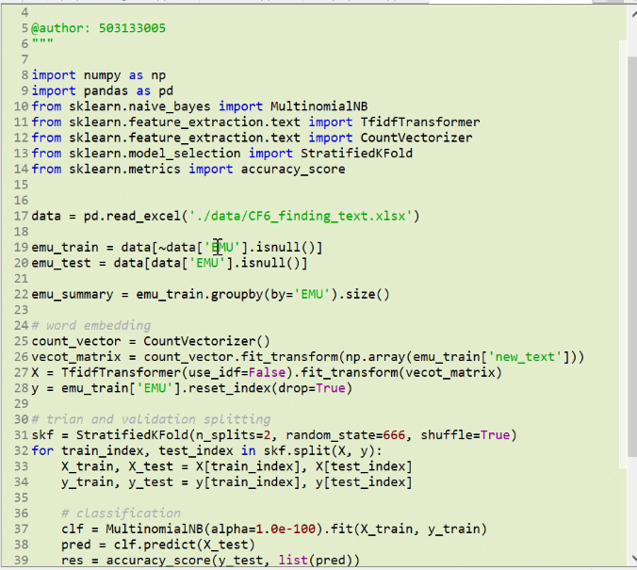

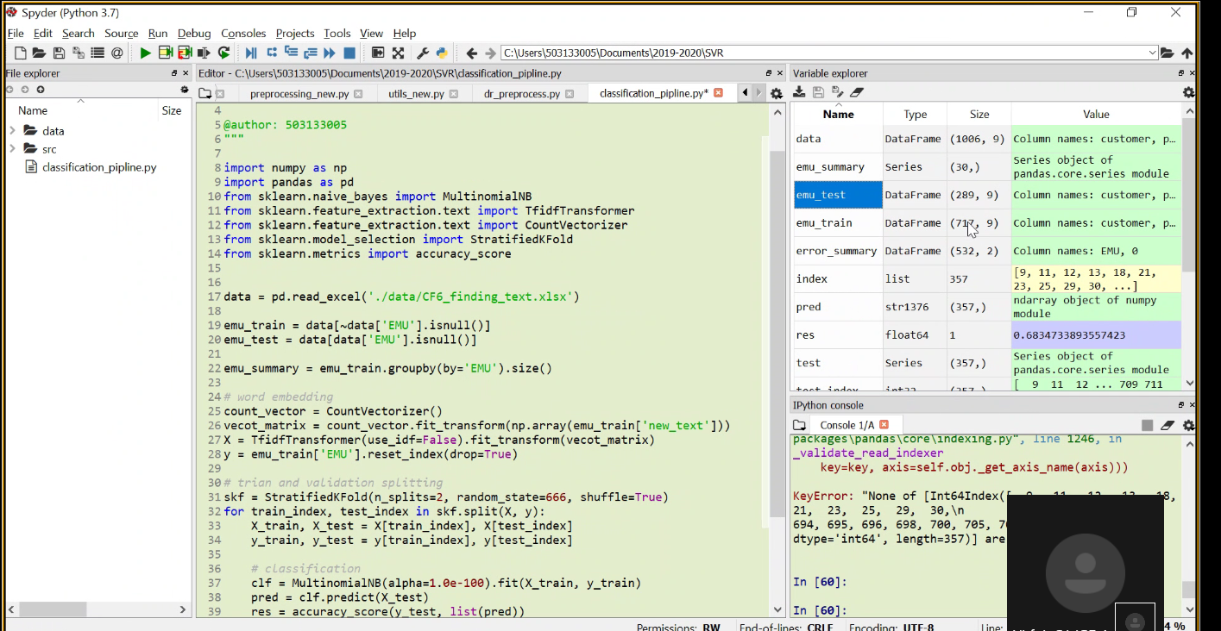

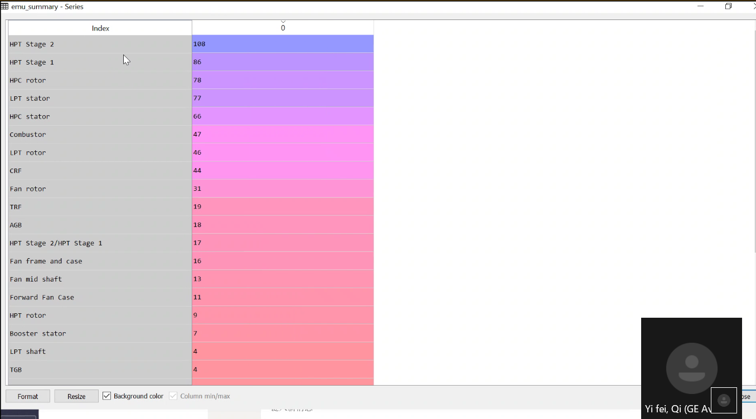

![Machine generated alternative text:
Index 
103 
116 
156 
157 
2ø1 
202 
2ß5 
237 
255 
274 
Format 
emu train - DataFrame 
811-2m 
811-22m 
811-2k 
811-11 
811-17 
811175 SHOP 
re5 - gem 
7e5-2æ 
811-63m 
811-6m 
x 
customer 
Aircalin 
Aircalin 
Aircalin 
Aircalin 
Aircalin 
Aircalin 
Aircalin 
Airbus 
Airbus 
pdf_name 
706872 
201410-Ac1 
811208 
201610-ACI 
811220 
201610-ACI 
811220 
2018e3-AC1 
811175 
20180 -ACI 
811175 
201803-ACI 
201 go-ACT 
811175 
SHOP 
201 goa-AHK 
705301 
2019øa-AHK 
705301 
201705 -AIB 
811635 
201705 -Arg 
811635 
201901 -AMA 
704199 
201901-AMA 
704199 
ESN 
201 gel -ANA 
704199 
201901-ANA 
704199 
ESN 
201608-ASAL 
704/99 
-79m 
201609-ASAL 
702690 
SHOP 
201609 ASAL 
702690 
SHOP 
201906-AZA 
page 
Module 
ACI 
ACI 
ACI 
ACI 
ACI 
ACI 
AHK 
AIB 
A 1B 
ASA L 
ASAL 
ASAL 
AerSale 
AerSaIe 
AerSale 
HPT 
HPT 
HPT 
HPT 
HPT 
HPT 
HPT 
Core 
HPT 
HPT 
HPT 
HPT 
HPT 
APT 
APT 
APT 
RPT 
APT 
APT 
RPT 
RPT 
RPT 
RPT 
EMU 
stage 
Stage 
stage 
Stage 
stage 
Stage 
stage 
Stage 
stage 
Stage 
stage 
Stage 
stage 
Stage 
stage 
Stage 
Stage 
Stage 
stage 
SPM 
nan 
Burn 
Rub 
nan 
nan 
nan 
nan 
Crack/"ear 
Rub 
nan 
nan 
Rub 
Groove/wear 
nan 
nan 
nan 
Crack 
nan 
Erosion/ Rub 
ESN 
11208 
122ø 
1220 
1175 
11175 
1175 
1175 
5301 
5301 
1635 
11635 
199 
ea199 
2699 
Engine rating 
CF6-8øCEIAa 
-8eEIA4 
CF6-8eEIAa 
-8eEIA4 
CF6-8øEIAa 
CF6-8eEIAa 
nan 
nan 
CF6-8eEIA48 
CF6-8eEIAAB 
nan 
nan 
nan 
nan 
-8øC2BIF 
CF6-8øc2BIF 
-8øC2BIF 
nan 
new text 
blades cleani.„ 
APT stage-2 
Blades found 
All HPT stage 
2 nozzles werm 
APT STG-I & 
STG-2 shroudsm 
Found one of 
HPT stage 2 1m 
ee tra 
All RPT STG 
cd 
Found one of 
gr•1A on pon, 
Found cracks 
on HPT stage-m 
a) Rub surface 
for: (a) 
Core 3R 
Journal HPTm 
SR Journal, 
APT stage 2 
Found all the 
stage 2 bladem 
CircumferentE 
Found some HPT 
stage 2 shrou„ 
Position Upper 
middle Lowerl.„ 
HPT stage-2 
blades were fm 
APT stage 
nozzles: crac 
HPT stage-2 
nozzle were fm 
Found the APT 
AZA Alitalia 
Resize Background color Column min/max 
Yi fei, ](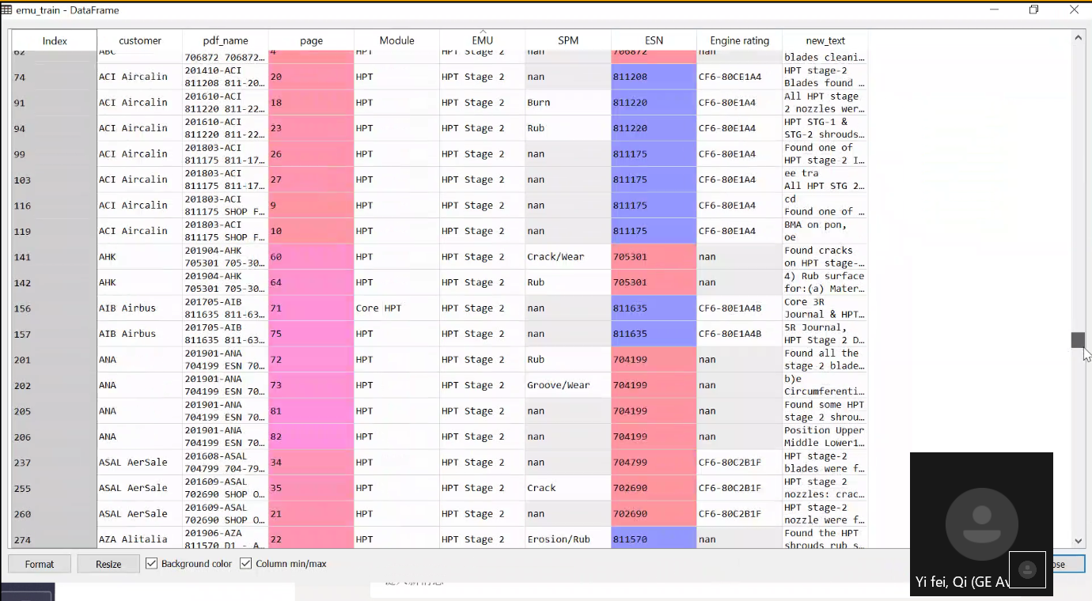)

<<Yifei.wmv>>

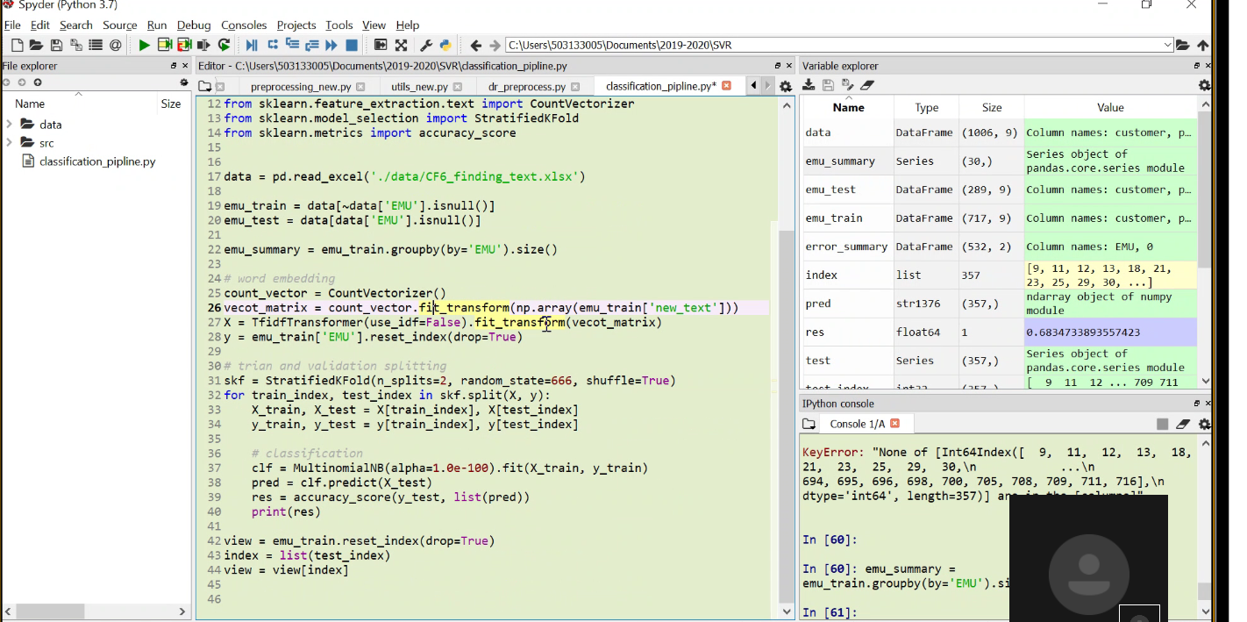

Video recording started: 4:40 PM Friday, April 24, 2020

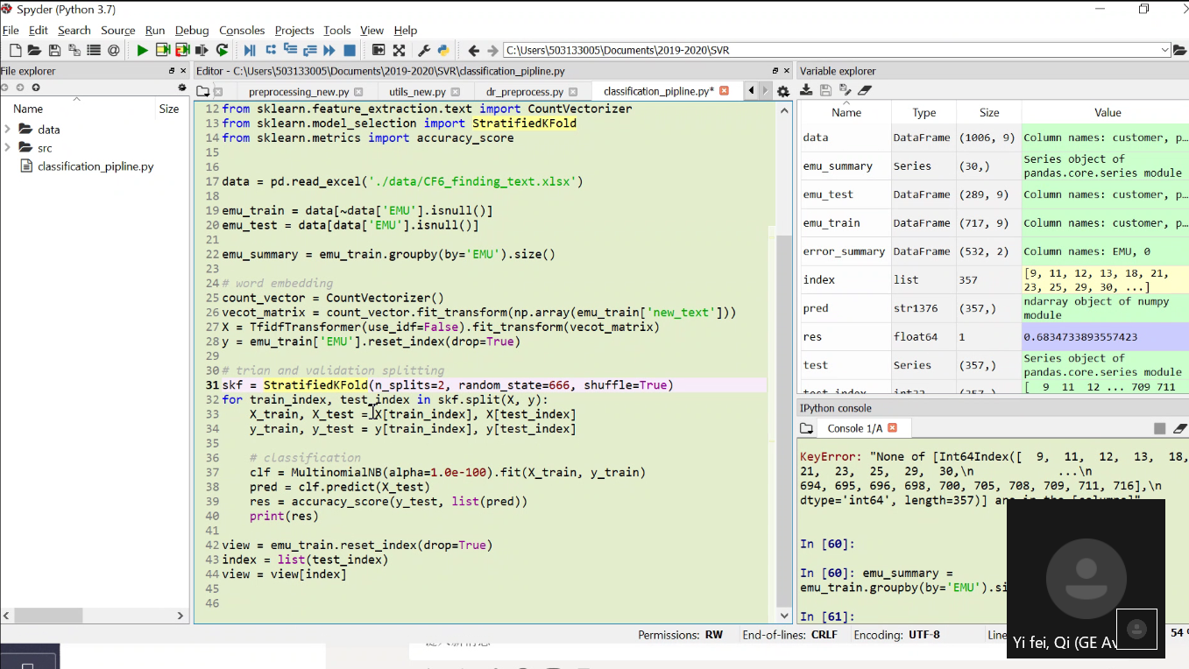

![Machine generated alternative text:
Spyder (Python 3.7) 
Eile Edit Search Source Run Debug Consoles Projects Tools View Help 
x 
File explorer 
Name 
data 
6 x Editor - 
Size 12 from 
13 from 
14 from 
15 
dassification_pipline.py 
prepr new _ py 
o 
utils_new_ py 
o 
dr_p repr ocess_ py 
5k learn. feature_extraction. text import CountVectorizer 
sklearn.model_selection import StratifiedKF01d 
sklearn.metrics import accuracy _ score 
17 data = pd. ' . 
Variable explorer 
Name 
data 
Type 
Data Frame 
Series 
Data Frame 
DataFrame 
Data Frame 
list 
stri276 
floatEA 
Series 
Size 
Value 
classification_pipline.py 
18 
emu train = 'EMU']. isnull()] 
19 
2e emu test 
= emu_train. EMU ) . size() 
22 emu_summary 
23 
249 word embedding 
CountVectorizer() 
25 count vector = 
6 vecot matrix = count _ vector. 'new_text ' 
27 X = TfidfTransformer(use_idf=False) . fit _ transform(vecot_matrix) 
emu 
emu 
emu 
summary 
test 
train 
(lams, 
(30, ) 
(289, 
(717, 
(522, 
357 
(357,) 
(357,) 
sens 
9) 
9) 
g) 
2) 
28y emu _ train( ' EMI—I' . 
trion and validation splitting 
31 skf 
32 for train _ index, test _ index in skf.sp1it(X, y): 
error summary 
index 
pred 
res 
test 
IPython console 
Col umn 
names: customer, p. _ 
object of 
series 
pandas. core. series module 
Col umn 
names: customer, p. _ 
column 
names: customer, p.„ 
Column 
names: EMU, 
[g, 11, 
12, 13, 18, 21, 
29, 30, ...l 
23, 25, 
ndarray object of numpy 
module 
o. 6834733893557423 
Series object of 
pandas. core. series module 
shuffle=True) 
y _ train) 
Permissions: 
9 11 12 
cumen s 
709 711 
33 
35 
36 
37 
38 
41 
X_train, X_test = 
y _ train, y _ test = 
# classification 
clf = . fit(X_train, 
pred 
res = accuracy_score(y_test, list(pred)) 
print(res) 
Console 1 IA 
run e 
2 view = 
43 index = 
view 
46 
emu_train. reset_index(drop=True) 
list(test_index) 
view(index) 
2319-2e2e/SVR/c1assification_pip1ine . py', wdir= 
users/ se3133ee5/Documents/ ' ) 
e. 7e83333333333334 
e. 6834733893557423 
C : \anaco 
least populated class in y ha 
too few. The minimum number o 
cannot be less than n _ splits: 
% (min_groups, self.n_split 
C: \Users \anaco 
ba es. : 48e: 
RW 
End-of-lines: CRLF 
Encoding: UTE-8 
Yi fei, Qi (GE A ](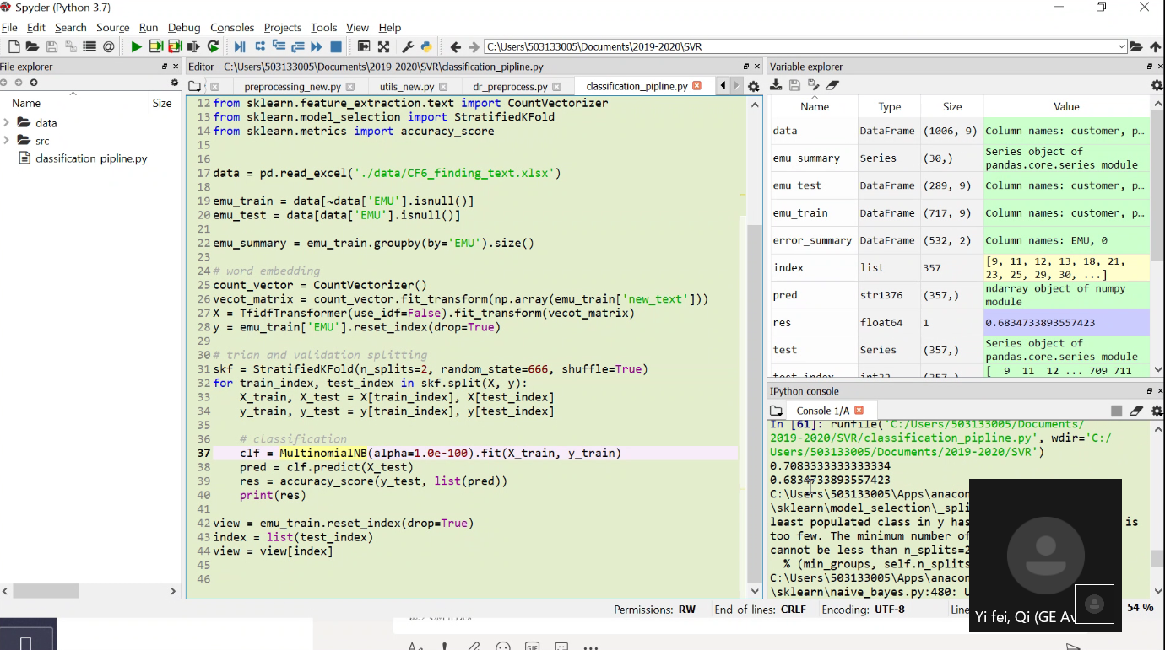)

![Machine generated alternative text:
Spyder (Python 3.7) 
Eile Edit Search Source Bun Qebug Consoles projects 1001s View Help 
x 
File explorer 
Name 
data 
classification_pipline.py 
6 x Editor - 
dassification_pipline.py 
Size 
•z 
prepr ocessing_new _ py 
o 
utils_new_ py 
o 
dr_p repr ocess_ py 
z 
8 import numpy as np 
9 import pandas as pd 
sklearn. naive_bayes import MultinomialNB 
le from 
11 from 
12 from 
13 from 
14 from 
IS 
16 
17 data = 
18 
Variable explorer 
Name 
data 
Type 
Data Frame 
Series 
Data Frame 
DataFrame 
Data Frame 
list 
floatEA 
Series 
Size 
(lae6, 9) 
Value 
sklearn. feature_extraction. text import TfidfTransformer 
sklearn. feature_extraction. text import Countvectorizer 
sklearn.model_selection import StratifiedKF01d 
sklearn.metrics import accuracy _ score 
pd. ' . ) 
' EMU ' ] 
19 emu train 
— data[data[ EMU ' 
e emu test — 
21 
22 emu_summary = ' ) . size() 
23 
249 word embedding 
— CountVectorizer() 
5 count vector — 
26 vecot matrix = count _ vector. 'new_text ' 
7 X . fit _ 
emu 
emu 
emu 
summary 
test 
train 
(30, ) 
(289, 
(717, 
(522, 
357 
(131,) 
(357,) 
9) 
g) 
2) 
error summary 
index 
pred 
res 
test 
IPython console 
Console 1 IA 
Col umn 
names: customer, p. _ 
object of 
series 
pandas. core. series module 
Col umn 
names: customer, p. _ 
column 
names: customer, p.„ 
Column 
names: EMU, 
[g, 11, 
12, 13, 18, 21, 
29, 30, ...l 
23, 25, 
ndarray object of numpy 
module 
o. 7557251908396947 
Series object of 
pandas. core. series module 
11 18 21 
7øø 705 
28y = emu _ trainl ' EMU' ] . 
29 
trian and validation splitting 
31 skf = random_state=666, 
32 for train _ index, test _ index in skf y): 
33 
34 
36 
37 
39 
411 
42 
X _ train, X_test = 
y_train, y_test = yttrain_index], yttest_index) 
# classification 
clf . 
pred = clf.predict(X_test) 
res — accuracy_score(y_test, 
list (pred)) 
print(res) 
shuffle=True) 
y _ train) 
Permissions: 
In [62]: runfile( 'C: /Users/Se3133B3S/Documents/ 
2019-2e2e/SVR/classification_pipline . py', 
Users/se3133ee5/Documents/ 2e19-2828/svR ' ) 
e. 74 
e. 675862e689655173 
e. 72e5882352941176 
e. 75572519e8396947 
C : \lJsers \anaco 
least populated class in y ha 
too few. The minimum number c 
RW 
End-of-lines: 
CRLF Encoding: UTE-8 
Lin 
Yi fei, Qi (GE A 
52 % ](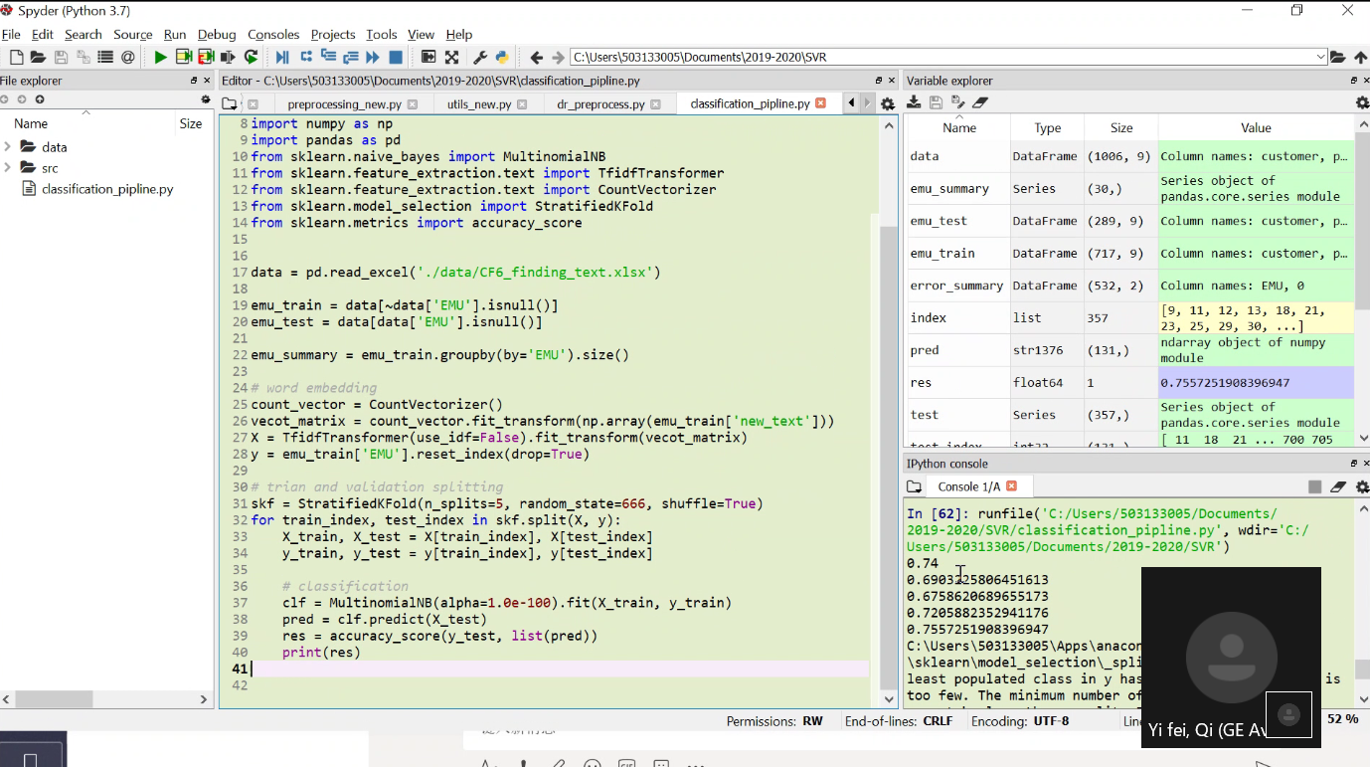)

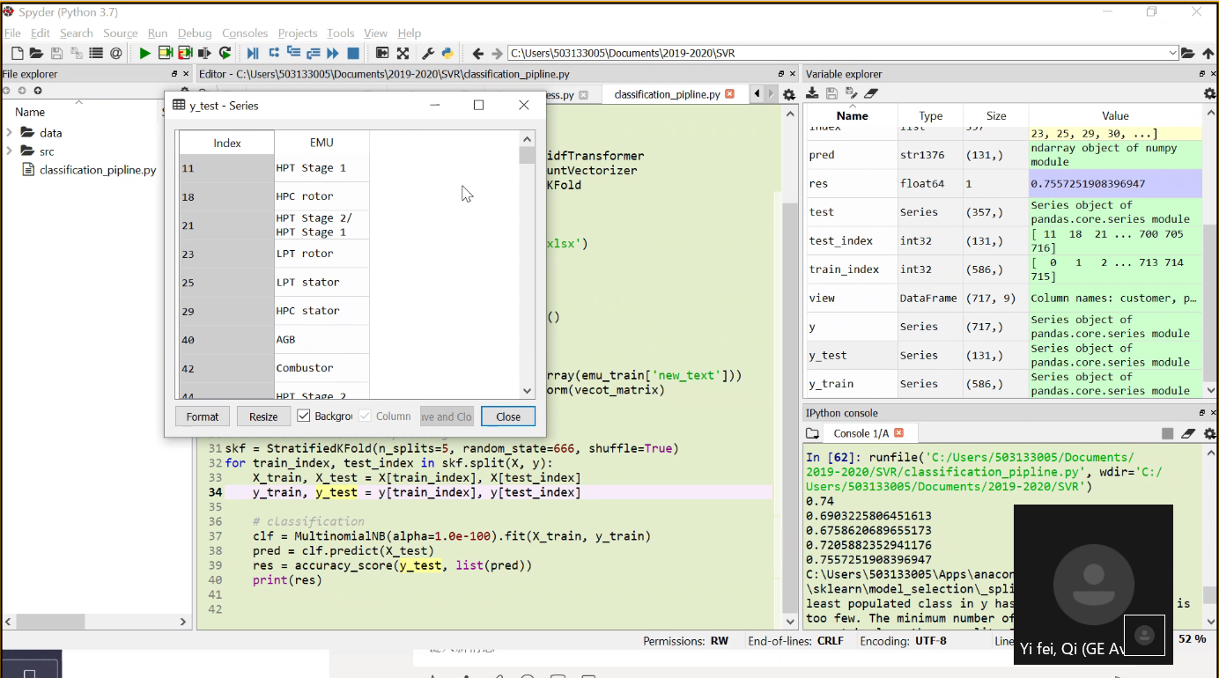

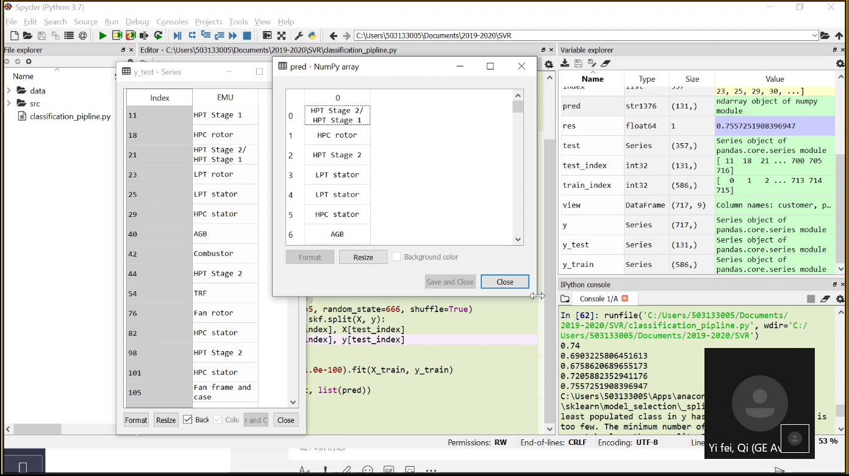

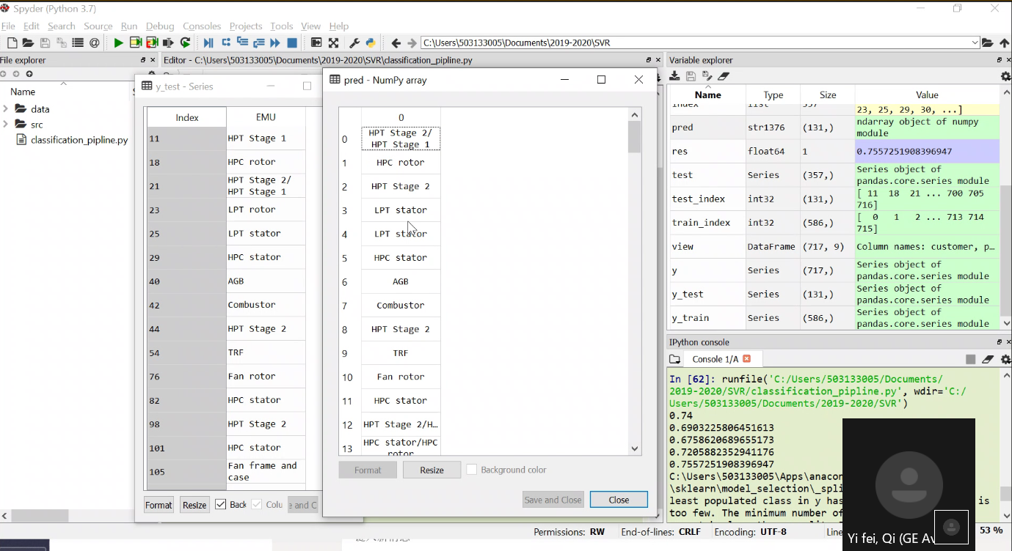

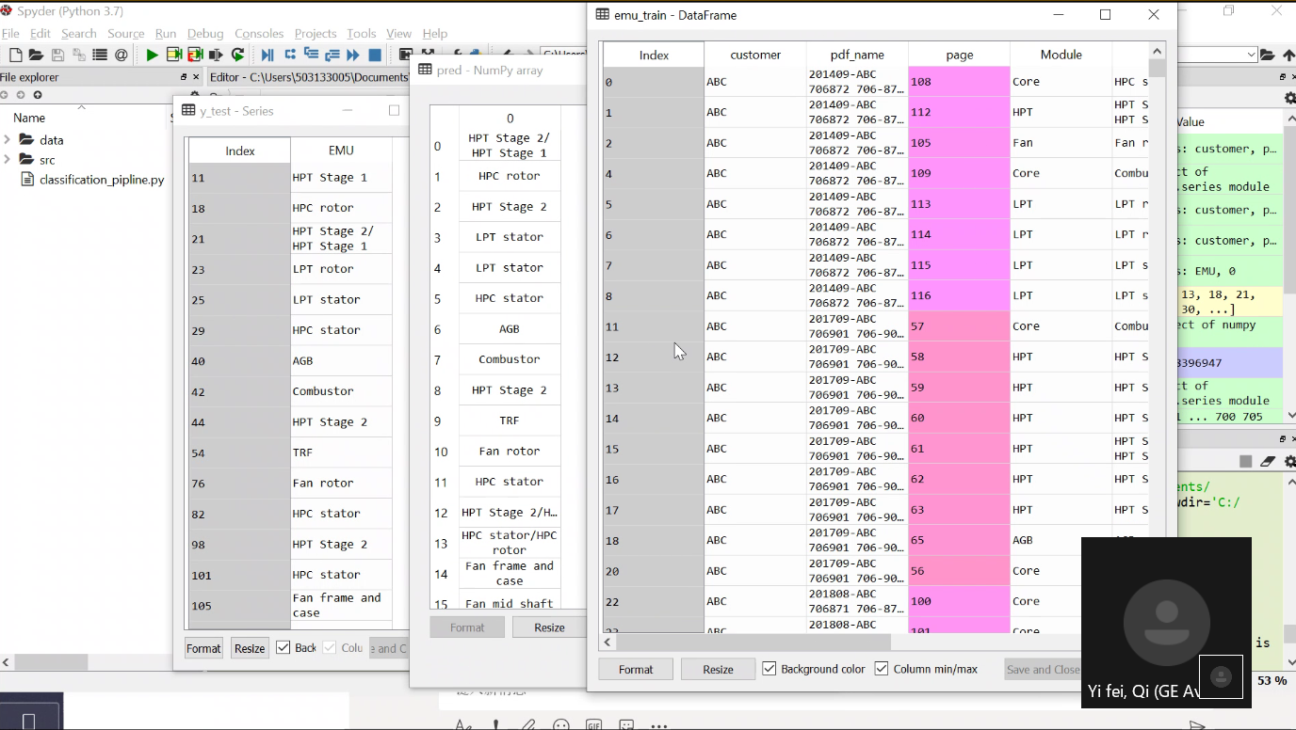

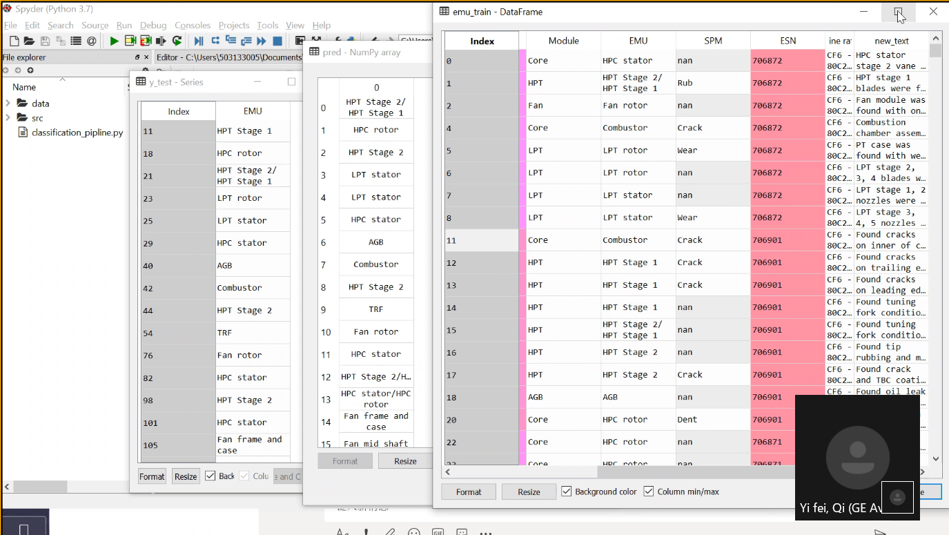

![Machine generated alternative text:
Spydpr (Python 47) 
File Edit Search Source Kun Qebug Consoles Projects Lools View Help 
706-8m 
706-8m 
706-8m 
706-8m 
706-87 
ile explorer 
Name 
data 
classification_pipline.py 
6 x Editor - 
Size 
CJ preprocessing_new_ py 
dr_preprocess_ py 
9 import pandas as pd 
. feature_extraction. text import TfidfTransformer 
Variable explorer 
Name 
data 
Size 
Value 
le from 
11 from 
12 from 
13 from 
14 from 
15 
16 
17 data 
sklearn. naive_bayes import MultinomialNB 
sklearn 
sklearn. feature extrac 
sklearn.model selecti 
sklearn. metrics import 
= pd. . /dat 
emu train - DataFrame 
19 emu train = 'EMU 
2e emu test 
= emu_train.gr 
22 emu_summary 
word embedding 
25 count vector Countvectori 
6 vecot matrix = count vector 
27 X = TfidfTransformer(use_id 
28y emu _ train(' EMU' 
. reset_ 
29 
3es trion and wc/_idaticn spli 
StratifiedKF01d(n_sp1 
31 skf = 
32 for 
train index, test index 
X _ train, X _ test X[tra 
33 
y _ train, y _ test = y[tra 
34 
35 
# classification 
CIF = 
37 
pred 
38 
res = accuracy_score(y_test, 
print(res) 
42 emu 
Index 
Resize 
ee-lee) . fit(X_ 
list (pred)) 
customer 
pdf name 
201409-ABC 
706872 
201409-A8C 
7ß6872 
201409-ABc 
706872 
201409-A8C 
7ß6872 
201409-ABc 
706872 
201409-A8C 
7ø6872 
201409-ABc 
706872 
201409-A8C 
7ø6872 
page 
Close 
emu 
emu 
emu 
summary 
test 
train 
Type 
Data Frame 
Series 
Data Frame 
DataFrame 
Data Frame 
list 
stri276 
floatEA 
Series 
(lae6, 
(30, ) 
(289, 
(717, 
(522, 
357 
(121,) 
(357,) 
9) 
9) 
9) 
2) 
error summary 
index 
pred 
res 
test 
IPython console 
Col umn 
names: customer, p. _ 
object of 
series 
pandas. core. series module 
Col umn 
names: customer, p. _ 
Column 
names: customer, p.„ 
Column 
names: EMU, 
[g, 11, 
12, 13, 18, 21, 
29, 30, ...l 
23, 25, 
ndarray object Of numpy 
module 
o. 7557251908396947 
Series object of 
pandas. core. series module 
11 18 21 
7øø 705 
console I/'A 
s earn naxve_ ayes . py 
small will result in 
numeric 
I.ee-le 
setting alpha = % 
se arnzng: a p a 00 
errors, setting alpha = 
Backgro Column 
train, y _ train) 
've and CIO 
.1e' % _ ALPHA_MIN) 
C : \Users \anaco 
\ sklearn . py : 48e : 
small will result in numeric 
I.ee-le 
' setting alpha X. le 
train = emu_train. reset_index(drop=True) 
Permissions: 
RW 
In 64 
End-of-lines: 
CRLF 
emu train emu 
Encoding: UTE-8 
trai 
Lin 
Yi fei, Qi (GE A 
53 % ](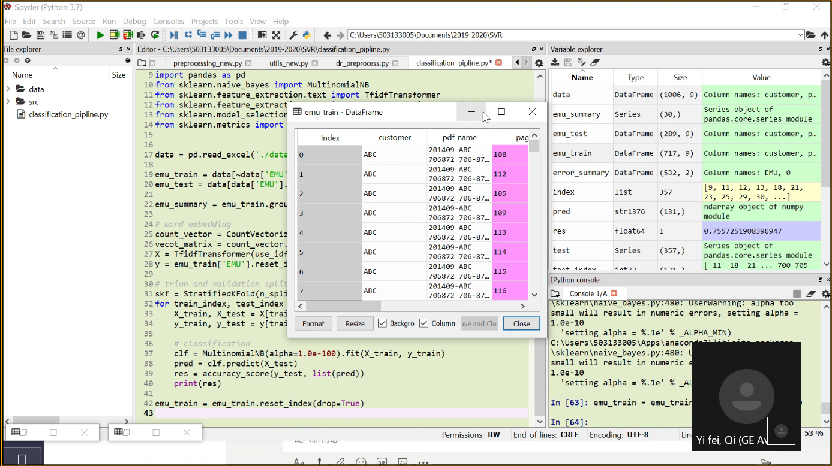)

![Machine generated alternative text:
emu train - DataFrame 
7e6-81.„ 
7%-87 
7e6-81.„ 
7e6-87 
7e6-81.„ 
7e6-87 
7e6-81.„ 
7%-87 
7e6-ge.„ 
7e6-ge.„ 
7e6-ge.„ 
7e6-87 
7e6-81.„ 
x 
Index 
Format 
customer 
pdf_name 
page 
Module 
core 
HPT 
Fan 
Core 
LPT 
LPT 
LPT 
LPT 
core 
APT 
HPT 
HPT 
core 
Core 
Core 
HPC 
RPT 
Fan 
EMU 
stator 
Stage 
Stage 
rotor 
SPM 
Engine rating 
ABC 
ABC 
ABC 
ABC 
ABC 
ABC 
ABC 
ABC 
ABC 
ABC 
ABC 
Agc 
ABC 
ABC 
ABC 
ABC 
ABC 
ABC 
ABC 
Resize 
201409-AdC 
706872 
201ae9-ABc 
706872 
201409-AdC 
706872 
201ae9-ABc 
706872 
201409-AdC 
706872 
201ae9-A8c 
706872 
201409-AdC 
706872 
201ae9-A8c 
706872 
201709 -ABC 
706901 
706901 
201709-AdC 
706901 
•al 7Ø9.Agc 
7a69Ø1 
706 
201709 
706901 
7e6 
706901 
201709-AdC 
706901 
706901 
201709 -ABC 
706901 
201808 -ABC 
706871 
201808 -ABC 
706871 
Combustor 
new text 
HPC stator stage 2 vane segments were found 
with missing Teflon seal. HPC stator case wa.„ 
RPT stage 1 blades were found with coating 
missing, corrosion, and tuning fork conditio__ 
Fan module was found with one fan stage 1 
blade trimmed 
Combustion chamber assembly was found with 
cracks on outer and inner liner. 
PT case was found with wear on inside support 
ring slots. stage 1 blades were found wi.„ 
LPT 
LPT 
rotor 
rotor 
stator 
stator 
CPT stage 
corrosion. 
LPT stage 
corrosion. 
CPT stage 
corrosion. 
2, 4 blades were found with 
1, 2 nozzles were found with 
EGT probe was broken during disas.„ 
3, 4, 5 nozzles were found with 
LPT stage S nozzle was found with__ 
combustor 
_ 90. 
16e 
RPT 
HPT 
RPT 
HPT 
HPT 
RPT 
HPT 
HPC 
HPC 
HPC 
Sta ee 
stage 
Sta ee 
stage 
stage 
Sta ee 
stage 
rotor 
rotor 
rotor 
2/ 
nan 
Rub 
nan 
Crack 
nan 
nan 
Wear 
crack 
Crack 
crack 
nan 
nan 
nan 
crack 
nan 
nan 
nan 
6872 
6872 
6872 
6872 
6872 
6872 
6872 
6872 
6901 
6901 
4e69ø1 
7ø69a1 
e69ø1 
6901 
6901 
6901 
6901 
6871 
6871 
CF6 
cF6 
CF6 
CF6 
CF6 
CF6 
CF6 
CF6 
CF6 
CF6 
CF6 
8øC2d5F 
80C2B5F 
8øC2d5F 
80C2B5F 
8øC2d5F 
8øc2B5F 
8øC2d5F 
80C2B5F 
8øC2B5F 
80C2B5F 
8øc2d5F 
gaugsF 
8øC2d5F 
80C2B5F 
8øC2d5F 
80C2B5F 
8øC2d5F 
80C2B5F 
8øC2B5F 
Found cracks on inner of combustor 
Found cracks on trailing edge of RPT stage 1 
nozzles 
Found cracks on leading edge of HPT stage 1 
nozzles 
Found tunine fork condition on HPT st aeo 1 
bl ades 
Found tuning fork condition and tip damage on 
HPT stage 1 blades 
Found 
stage 
Found 
stage 
Found 
Found 
stage 
tip rubbing and material missing on RPT 
2 blades 
crack and TBC coating missing on HPT 
2 nozzles 
oil leak trace on AGR module 
dent on HPC 
1 blades trailin 
Background color Column min/max 
HPC rotor stage 1, 3, 
With bend and nicks. 
HPC rotor stage 8, 9, 
with bend and nicks. 
Yi fei, ](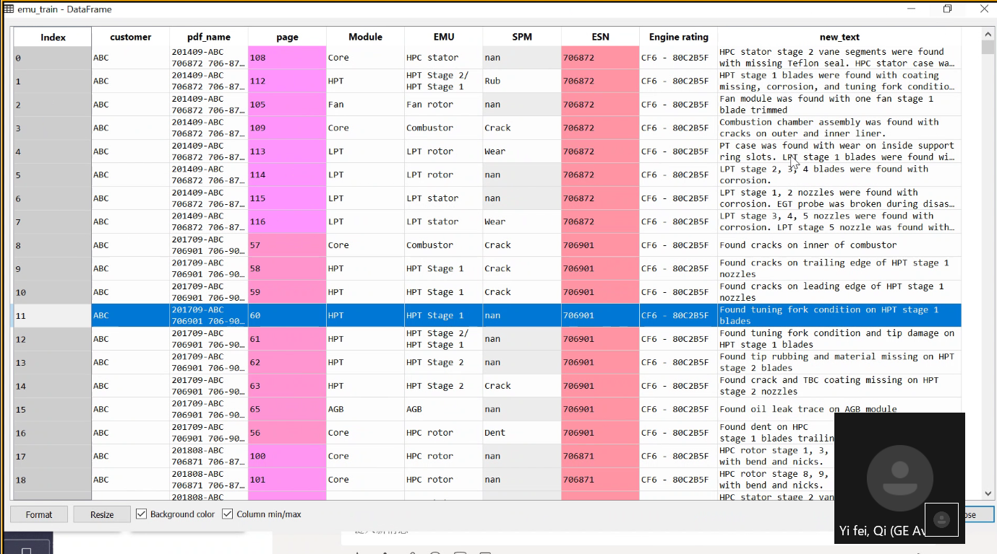)

![Machine generated alternative text:
Index 
473 
193 
289 
136 
171 
172 
189 
226 
424 
Format 
emu train - DataFrame 
7e6-87 
7e6-9e. 
7%-87 
7e6-87 
customer 
FedEx 
AZA Alitalia 
FedEx 
ABC 
ABC 
ABC 
ABC 
ABC 
ABC 
ACI Aircalin 
pdf_name 
702211 
7e2-2E 
201106 
702829 
201802-EVA 
811375 
811375.„ 
201ge6-AZA 
811570 DI Am 
201607 -FDX 
FedEx 
702850 
201ge8-A8c 
706872 
201508 
EVA 
811323 
201409-A8C 
706872 
201709-ABC 
706901 
201808 -ABC 
706871 
201808-ABC 
706873 
201810-A8C 
706872 
201410-ACI 
811-2e.„ 
page 
Module 
HPT 
EMU 
Stage 
Stage 
stage 
Stage 
RPT 
RPT 
RPT 
RPT 
HPT 
RPT 
RPT 
RPT 
HPT 
RPT 
HPT 
RPT 
RPT 
RPT 
RPT 
RPT 
HPT 
3/ 
2/ 
SPM 
Burn 
nan 
nan 
HPT 
Core 
Core 
HPT 
HPT 
HPT 
HPT 
HPT 
HPT 
HPT 
rotor/HPC.„ 
stage 2/ 
nan 
rotor/Hpc.„ 
ASAL 
ASAL 
Aersale 
AerSa1e 
811208 
201901 -AMA 
704199 
201609-ASAL 
702690 
s HOP 
201609 -ASAL 
702690 SHOP 
201906-AZA 
811570 
DI - 
201105 
8111B 
201602-FDX 
702360 
201602 
702360 
o.„ 
AZA Alitalia 
BEL Brussel 
FedEx 
FedEx 
Resize 
811-10„ 
FedEx 
Stage 
Stage 
stage 
stage 
Stage 
Stage 
stage 
stage 
Stage 
Stage 
stage 
stage 
Stage 
Stage 
stage 
stage 
Stage 
Stage 
stage 
stage 
Stage 
Stage 
stage 
stage 
Stage 
Stage 
stage 
stage 
Stage 
Sta e 
2/ 
2/ 
2/ 
2/ 
2/ 
2/ 
2/ 
2/ 
2/ 
2/ 
2/ 
2/ 
2/ 
2/ 
Dent/Crack 
nan 
Rub 
nan 
Wear 
Rub 
Burn 
Rub 
nan 
nan 
nan 
nan 
crack 
nan 
ESN 
2829 
1375 
1570 
2850 
6872 
1323 
6872 
6901 
6871 
6873 
6872 
1208 
199 
2690 
2690 
1570 
11B 
2360 
2360 
Engine rating 
CF6-8øC2DIF 
nan 
nan 
CF6 
80C2DIF 
nan 
nan 
CF6 
- 8ØC285F 
CF6 
80C2B5F 
CF6 
- 8ØC285F 
CF6 
80C2B5F 
nan 
CF6-8øcEIAa 
nan 
CF6-8øc2BIF 
CF6-8øC2BIF 
nan 
-8eFIA2 
CF6 
80C2DIF 
CF6 
- 8ØC2DIF 
Background color Column min/max 
new text 
Found burn on outer platform of HPT stage 1 
nozzle. 
HPT case external condition normal 
La LAY 
Item 1, 2: core 3R Journal HPT stage 2 Disk 
Aft Flange F.R 
HPT stage 2 blade (visually check with mirror) 
perform visual inspection and touch by finge.„ 
APT stage 2 blade seal bodies (P/N: 1957M35pa3) 
3 EA found broken 
ition. RPT stage 2 blades we;e found with rub on tip of blade. 
Found tuning fork con tion and tip damage on 
HPT stage 1 blades 
HPT stage 1 blades were found with coating 
missing, heavy wear and material missing on „ 
HPT stage 1 blades were found with coating 
missing. HPT stage 2 blades were found with 
HPT stage 1 blades were found with coating 
missing, corrosion, and tuning fork conditio.„ 
Found HPT stage 1 2 shroud burn mark. 
2 Thal ie 
HPT stage I shrouds: Typical w wear. 
HPT stage 2 shrouds: Typical wear. 
HPT stage 1 blades: Dirty. 
APT stage 1 g stage 2 
deterioration 
HPT stage 1 and 2 shr 
wear. 
jo RmA 7e2- 
sex 9 
(a) HPT stage 2 nozzle 
RBM . a ii ii 
Sta e 1 shrouds 
Yi fei, Qi (GE A ](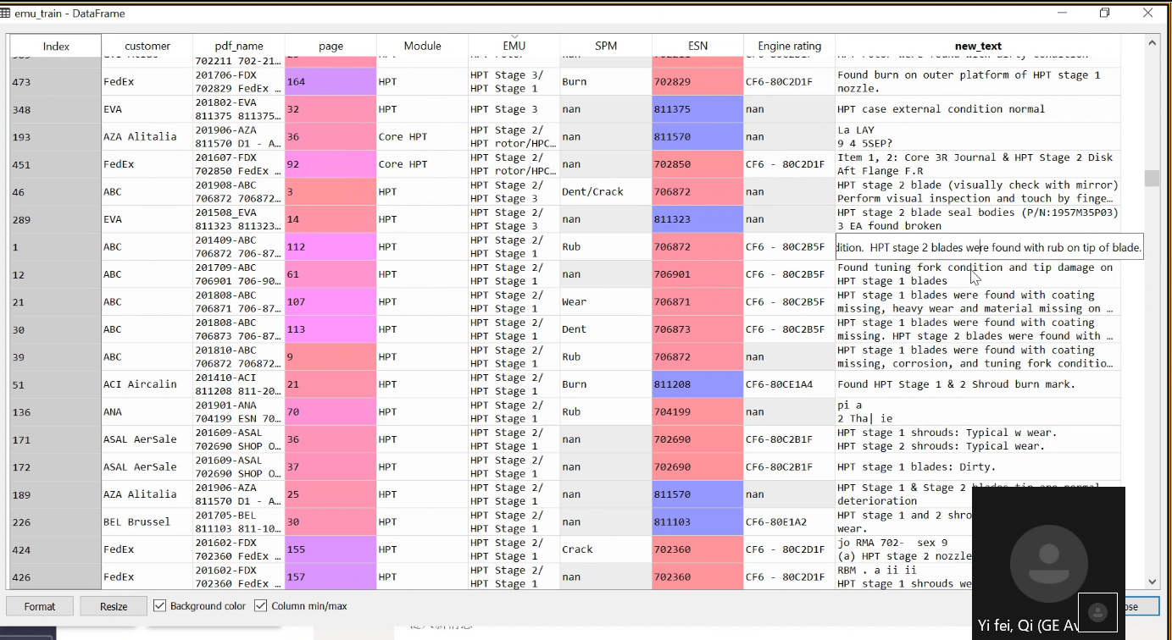)

![Machine generated alternative text:
Spyder (Python 3.7) 
Eile Edit Search Source Bun Debug Consoles projects Tools View Help 
x 
-le explorer 
Name 
data 
classification_pipline.py 
6 x Editor - 
classification_pipline.py* 
Size 
CD preprocessing_new. py 
dr_preprocess_ py 
o 
9 import pandas as pd 
Variable explorer 
Name 
data 
le from 
11 from 
12 from 
13 from 
14 from 
15 
16 
17 data 
sklearn. naive_bayes import MultinomialNB 
sklearn. feature_extraction. text import TfidfTransformer 
sklearn. feature_extraction. text import CountVectorizer 
sklearn.model_selection import StratifiedKF01d 
sklearn.metrics import accuracy _ score 
= pd. . 
Size 
(lae6, 9) 
(30, ) 
Col umn 
series 
Column 
column 
Column 
Value 
names: customer, p. _ 
object of 
emu 
emu 
emu 
summary 
test 
train 
text ' 
Type 
Data Frame 
Series 
Data Frame 
DataFrame 
Data Frame 
list 
stri276 
floatEA 
Series 
(289, 
(717, 
(522 
357 
(121,) 
(357,) 
9) 
9) 
19 emu train = • EMU 
] . isnull()] 
2e emu test 
= EMI-I ) . size() 
22 emu_summary 
word embedding 
— Countvectorizer() 
25 count vector — 
6 vecot matrix = count _ vector. 'new 
27 X = TfidfTransformer(use_idf=Fa1se) . fit _ transform(vecot_matrix) 
28y emu _ train( ' EMU' . 
29 
3es trion and validation splitting 
error summary 
index 
pred 
res 
test 
IPython console 
pandas. core. series module 
names: customer, p. _ 
names: customer, 
names: EMU, 
[g, 11, 
12, 13, 18, 21, 
29, 30, ...l 
23, 25, 
ndarray object of numpy 
module 
o. 7557251908396947 
Series object of 
pandas. core. series module 
11 18 21 
7øø 705 
31 skf = 
32 for 
train _ index, test _ index in skf. split(X, y): 
X _ train, X _ test 
33 
y _ train, y _ test = y[train_index , 
34 
35 
# classification 
CIF = . 
37 
pred 
38 
res = accuracy_score(y_test, list(pred)) 
print(res) 
train = emu_train . 
42 emu 
43 
shuffle=True) 
y _ train) 
Permissions: 
CJ console I/'A t: 
s earn naxve_ ayes . py 
se arnzng: a p a 00 
small will result in 
I.ee-le 
setting alpha = % 
numeric errors, setting alpha = 
.1e' % _ ALPHA_MIN) 
RW 
C: \Users \ Se3133ee5\Apps \anaco 
\ sklearn . py : 48e : 
small will result in numeric 
I.ee-le 
' setting alpha %.le' % _A 
In [63]: emu_train - 
— emu trai 
In 64 
End-of-lines: CRLF Encoding: UTE-8 
Yi fei, Qi (GE A 
53 % ](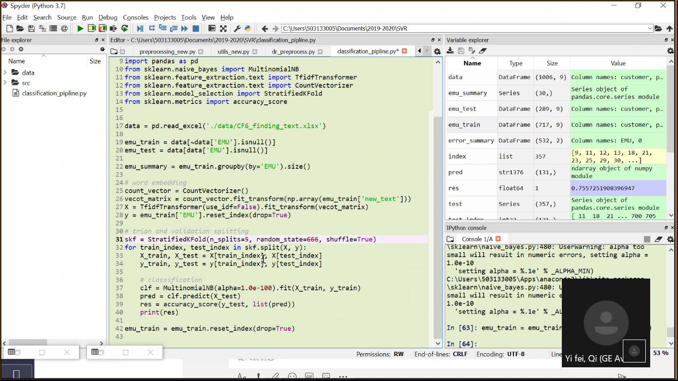)

![Machine generated alternative text:
emu train - DataFrame 
7e6-87.„ 
7e6-87 
7e6-87.„ 
7%-87 
7e6-87.„ 
7e6-87 
7e6-81.„ 
7e6-87 
7e6-ge.„ 
7e6-ge„ 
7e6-ge.„ 
7e6-ge.„ 
7e6-ge.„ 
7e6-87 
7e6-87.„ 
x 
Index 
Format 
customer 
ABC 
ABC 
ABC 
ABC 
ABC 
ABC 
ABC 
ABC 
ABC 
ABC 
ABC 
ABC 
ABC 
ABC 
ABC 
ABC 
ABC 
ABC 
ABC 
Resize 
pdf_name 
201409-Adc 
706872 
201ae9-ABc 
706872 
201409-AdC 
706872 
201ae9-ABc 
706872 
201409-AdC 
706872 
201ae9-ABc 
706872 
201409-AdC 
706872 
201ae9-ABc 
706872 
201709-AdC 
706901 
706901 
201709-AdC 
706901 
706901 
201709-AdC 
706901 
706901 
201709 -ABC 
706901 
706901 
201709-AdC 
706901 
201808 -ABC 
706871 
201808 -ABC 
706871 
page 
Module 
HPC 
RPT 
APT 
Fan 
EMU 
stator 
Stage 
Stage 
rotor 
2/ 
SPM 
nan 
Rub 
nan 
Crack 
wear 
nan 
nan 
Wear 
crack 
Crack 
crack 
nan 
nan 
nan 
crack 
nan 
nan 
nan 
ESN ine ra 
CFE 
7e68- 
8ec2. 
8øc2_ 
CFO 
7e68- 
8ec2m 
CF6 
Baca. 
CFO 
8ec2„. 
new text 
core 
HPT 
Fan 
Core 
LPT 
LPT 
LPT 
LPT 
core 
APT 
APT 
HPT 
core 
Core 
core 
Combustor 
LPT 
LPT 
rotor 
rotor 
stator 
stator 
combustor 
RPT 
HPT 
RPT 
HPT 
HPT 
RPT 
HPT 
HPC 
HPC 
HPC 
Sta ee 
stage 
Sta ee 
stage 
stage 
Sta ee 
stage 
rotor 
rotor 
rotor 
e found with missing Teflon 
HPC stator stage 2 vane segments 
seal. HPC stator case was found wi 
dirt and corrosion. 
RPT stage 1 blades were found with coating missing, corrosion, 
and tuning fork condition. HPT stage 2 blades were found with rum 
Fan module was found with one fan stage 1 blade trimmed 
- Combustion chamber assembly was found with cracks on outer and 
inner liner. 
PT case was found with wear on inside support ring slots. 
LPT stage 1 blades were found with corrosion. 
CPT stage 2, 3, 4 blades were found with corrosion. 
geck 
CF6 - LPT stage 1, 2 nozzles were found with corrosion. 
7e68- 
EGT probe was broken during disassembly . 
8ec2. 
CFS - CPT stage 3, 4, 5 nozzles were found with corrosion. 
8ßC2m LPT stage 5 nozzle was found with heavy wear at inner platform. 
CFO 
Found cracks on inner of combustor 
8ec2m 
Found cracks on trailing edge Of HPT stage 1 nozzles 
CFO 
Found cracks on leading edge of HPT stage 1 nozzles 
8ec2m 
Found tuning fork condition on RPT stage 1 blades 
geck 
CFO 
Found tuning fork condition and tip damage on HPT stage 1 blades 
7e69- 
8ec2„. 
Found tip rubbing and material missing On HPT stage 2 blades 
Baca. 
CFO 
8ec2m 
8øc2_ 
CFO 
8ec2„. 
7e68- 
paca. 
CFO 
7e68- 
8ec2m 
Background color Column min/max 
Found crack and TBC coating missing on HPT stage 2 nozzles 
Found oil leak trace on AGB module 
Found dent on HPC 
stage 1 blades trailing 
HPC rotor stage 1, 3, 4, 5 blades were f 
HPC rotor stage 8, 9, 12, la blades were 
nicks. 
Yi fei, ](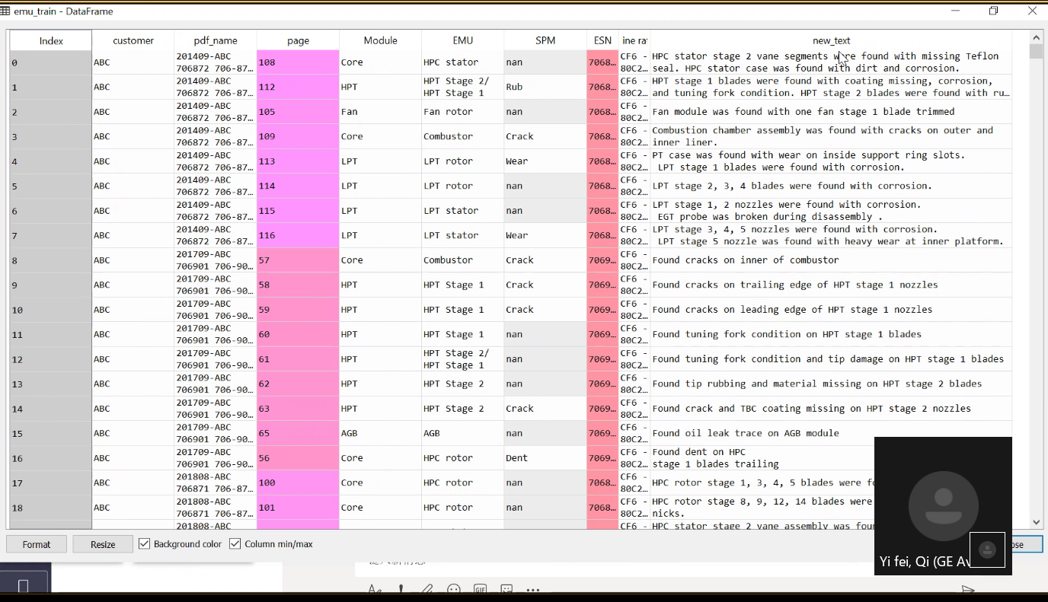)

![Machine generated alternative text:
Spyder (Python 3.7) 
Eile Edit Search Source Bun Debug Consoles Projects Tools View Help 
x 
•le explorer 
Name 
data 
classification_pipline.py 
6 x Editor - 
classification_pipline.py* 
Size 
0 preprocessing_new_ py 
dr_prep rocess_ py 
o 
9 import pandas as pd 
Variable explorer 
Name 
data 
Size 
(1006, 9) 
Value 
le from 
11 from 
12 from 
13 from 
14 from 
15 
16 
17 data 
sklearn.naive_bayes import MultinomialNB 
sklearn. feature_extraction. text import TfidfTransformer 
sklearn. feature_extraction. text import CountVectorizer 
sklearn.model_selection import StratifiedKF01d 
sklearn. metrics import accuracy _ score 
= pd. . 
emu 
emu 
emu 
summary 
test 
train 
19 emu train = 'EMU']. isnull()] 
2e emu test 
= EMI-I ) . size() 
22 emu_summary 
24? word embedding 
— Countvectorizer() 
25 count vector — 
6 vecot matrix = count _ vector. 'new 
27 X = TfidfTransformer(use_idf=Fa1se) . fit _ transform(vecot_matrix) 
28y emu _ train( ' EMU' . 
29 
3eg trior' and validation splitting 
text ' 
error summary 
index 
pred 
res 
test 
IPython console 
Type 
Data Frame 
Series 
Data Frame 
DataFrame 
Data Frame 
list 
stri276 
floatEA 
Series 
(30, ) 
(289, 
(717, 
(522, 
357 
(121,) 
(357,) 
9) 
g) 
2) 
Column 
names: customer, p. _ 
object of 
series 
pandas. core. series module 
Column 
Column 
Column 
[g, 11, 
23, 25, 
names: customer, p. _ 
names: customer, 
names: EMU, 
12, 13, 18, 21, 
29, 30, ...l 
ndarray object Of numpy 
module 
o. 7557251908396947 
Series object of 
pandas. core. series module 
11 18 21 
7øø 705 
se arnzng: a pa 00 
31 skf = 
32 for 
train _ index, test _ index in skf. split(X, y): 
X _ train, X _ test 
33 
y _ train, y _ test = 
34 
35 
# classification 
37 
clf . 
38 
39 
pred — 
res — accuracy _ score (y _ test, 
list (pred)) 
print(res) 
42 
train emu_train . 
43 emu 
shuffle=True) 
y _ train) 
Permissions: 
Console 1 IA 
s earn naxve_ ayes. py 
small will result in 
I.ee-le 
setting alpha = % 
numeric errors, setting alpha = 
.1e' % _ALPHA MIN) 
C : users \anaco 
\ sklearn py : 48e : 
small will result in numeric 
RW 
I.ee-le 
' setting alpha X. le 
In [63]: emu_train - 
— emu 
In 64 
End-of-lines: 
CRLF Encoding: UTE-8 
trai 
Yi fei, Qi (GE A 
53 % ](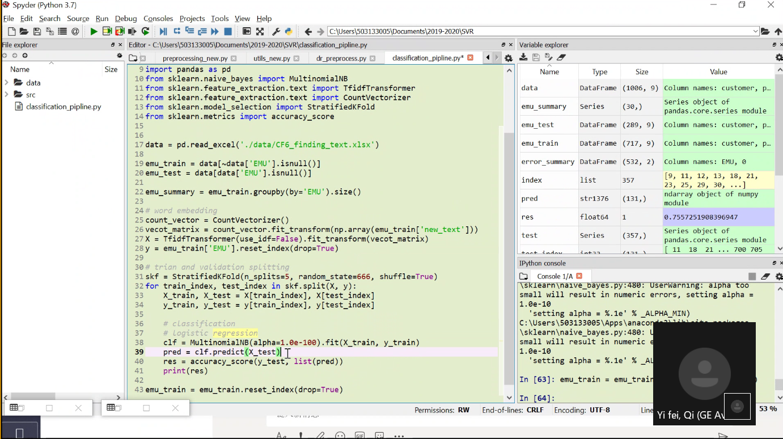)

1. 然后拿这个有EMU的（717条），我看了下717条里面一共有30种不同的EMU。数量是这样的HPT Stage2比较多，然后我发现里面有一些是HPT Stage1和Stage2同时都有的组合。这是一种组合呢，还是说它既可以是HPT Stage2也可以是HPT Stage1。这个文本里好像既有1也有2。

2. 然后做了一个简单的summary每个组合各占多少。像里面有些小的类，样本数量挺少的，像HPT Rotor往下都是10个以内的。像HPT Stage3只有1条记录。

3. 然后我用TFIDF的方法把它从free text这一列转换成了向量。这个X是TFIDF的transfermer的一个东西，暂时还展示不出来。但是如果展示出来的话，就是一个n维的矩阵。比如现在train的样本数量为717，那这个矩阵就有717行。然后列就得看它的词典，就是vacabulary的fence，就是你的free text里面一共有多少个词，它就一共有多少列。有的地方可能是有数字的，有的地方如果是没有这个词的话它就是0.然后这样把它变成向量，这个new text变成向量的话就是一个X，输入。Y就是EMU。

4. 我把它按照比例去分了一下，这里用的是一个stritified的分法，就是按照EMU的比例去分的。就是刚才看到的summary里面比如HPT有18条，我去分训练集和测试集的话，训练集9条测试集9条。然后CRS就是22条和22条的关系。如果是7折或者8折也是按比例去分的。这样我想测试一下这个模型的性能，还有其他的分法，比如随机的分法，那就不一定了，就是随机分我有可能HPT的18条都在训练集里面，可能没有测试集。就是另外一种分法，我现在用的是stritified的分法，然后是分成五五开，然后分成训练集和测试集。

5. 然后用了一个朴素贝叶斯的SKLearn里面的模型先去试了一下，试了一下它的准确率，就是有两份，我一共放了两份，那这两份的准确率差不多都是70%左右。70%不能说低，但也不高。等于说717条数据里面分成一半训练一半测试，得出这样一个结果。当然这个结果和很多东西都有关系，比如跟你分的东西有关。假如我把它换成一个5，5的话就是1：4，就是8：2，看一下结果，额，差不多还是70%左右。5的话就是分了5份，以8：2这样随机分了5次。看起来还是70%左右的一个准确率。

6. 之后可以从几个方面进行改进。

1）按照8：2的分法我的测试集有120条左右，里面有70%做对了，30%做错了。看到底因为什么原因做错了。把做错的地方做个误差分析。这不是有个Y吗，下面会分Y\_train和Y\_test，刚才分了5次这是最后一次的测试集，有131条数据。然后这时候再把你的结果拉出来看下，同时再把new text也拉进来。然后就把这些对比看下，比如HPT Satge1，这条就分错了分成HPT Stage1/HPT Stage2了。下面这条就是1和2只分到2了。另一条错在HPT Rotor分成了stator。对的和错的我觉得要一起去看。比如说把train拉出来，组合一下，看11是HPT Stage1 Y test它做错了，它对应的new text？我分的时候reset了一下它的index，啊对，train里面index没有reset过，现在把它reset一下。这样去看它的11的话就是HPT Stage1，这还挺明显的，它里面就是有HPT Stage1这个词，按理说不应该把它分到HPT Stage1&2里面，这样就分错了。这个就是数据上没有任何问题，是模型的问题。那模型的话可能要从HPT Stage1&2里面看一下，text部分按理说应该既有1也有2，他就有可能是模型没有学习到这个特征。从这儿到这儿都是1和2，里面都是既有也有2的。嗯，但是这里有一个不是既有1也有2的，但是它错误的分到了1和2。看下是不是没有显示完全的问题。如果显示完全了还分错了，那就有可能是模型学习到了错误的信息。像这里面的Stage1，就分成Stage1和2了，那它在我们刚刚看到的11的时候就有可能学习到了这种信息。大概就是这样去看一下，然后就是看下做错的那部分是因为什么做错的。

2）后面的话分成几折对结果没什么太大影响。还有的话就是做前面这个特征的时候是把每一个free text里面的词都去转换成了向量。它现在是按空格分的，比如HPT Stage每个空格是一个词，然后1和2数字也是放在里面的。那其实我们从数据里面想要的一些关键信息可能就是这种HPC Stators Stage，然后一些不关键的像were，was，and这种词，可以在前面的时候作为停用词去掉。这也是目前我还没错的一部分，我就是直接把全部数据拿来按空格去分，然后就塞到X里面去了。这是一个方向。

3）还有就是除了朴素贝叶斯以外还可以试下逻辑回归。因为逻辑回归的话也是一个很方便的模型，它可以输出概率，然后看一下它有的是模型自己不确定的时候输出的就是错的，然后因为它和朴素贝叶斯模型的机制也不一样，所以可以把这两种方法都去trial一下，看是不是逻辑回归的效果要更好一些。这个其实很简单就是from SKlearn import好像是leanr model，import 一个logistic regression。这个没关系我们后面再试一下。

4）然后模型里面有一些参数是可以调的，像逻辑回归里面的正则Y系数什么的。如果我们把数据处理还有数据本身对应的1和2的关系把它确认下来以后，看能不能把准确率提升一些。因为我们现在做的是stritified的分析方法，然后如果我们把有EMU的作为train数据，没有EMU的作为test数据，这个分布不一定是我们想象出来的训练集里有10个，测试集里有23个这种。它不一定是这种分布，有可能训练集1条都没有，有可能训练集有1条，测试集里有10条，也不一定。所以这个准确率我觉得理论上是要比这个低的。所以我在想能不能把这个准确率提升到80%以上，甚至90%，然后这时候我们就比较有信心去做没有标注的EMU这些了。然后这个如果标注起来，我们是不是可以发给GEEVES的人一条一条去review 一下。两百多条也不多嘛。我们先自己看下看289条逻辑上符合不符合，只看没有的，肉眼可以看出来一些，这好像看不出来cracks有是吧，这里面有的描述还挺奇怪的，这是一堆乱码。

我们现在有几个方向了，首先去看数据质量的问题，等于数据质量和误差分析是一块的。看下错在哪些地方，然后总结下，然后我这边同时还可以再试下逻辑回归的方法。再看准确率会不会比这个更好。